SESSION 5 ASSIGNMENT 2

## PROBLEM 1

### Q1.Find out the top 5 most visited destinations.

REGISTER '/usr/local/pig/lib/piggybank.jar';

A = load 'DelayedFlights.csv' USING org.apache.pig.piggybank.storage.CSVExcelStorage(',','NO_MULTILINE','UNIX','SKIP_INPUT_HEADER');

A_LIMIT = LIMIT A 5;

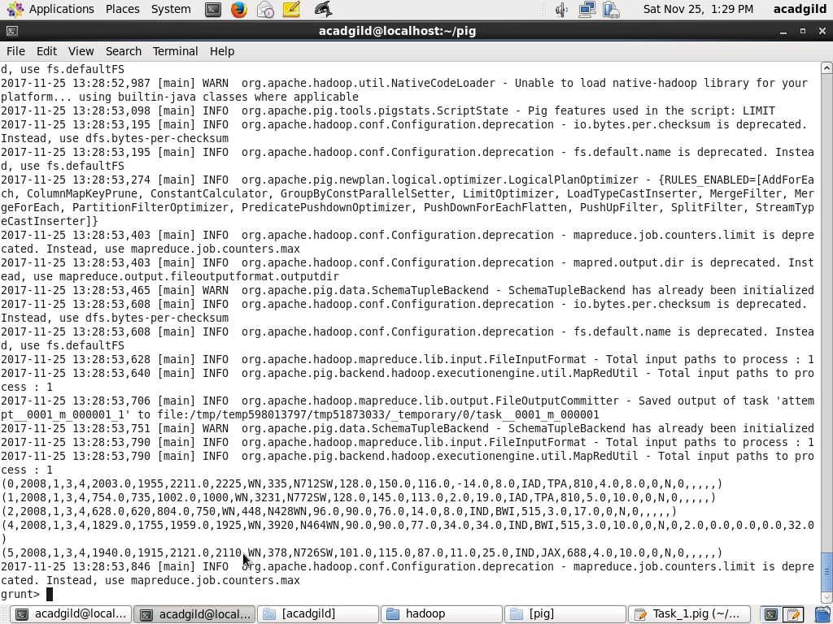

B = foreach A generate (int)$1 as year, (int)$10 as flight_num, (chararray)$17 as origin,(chararray) $18 as dest;

B_LIMIT = LIMIT B 5;

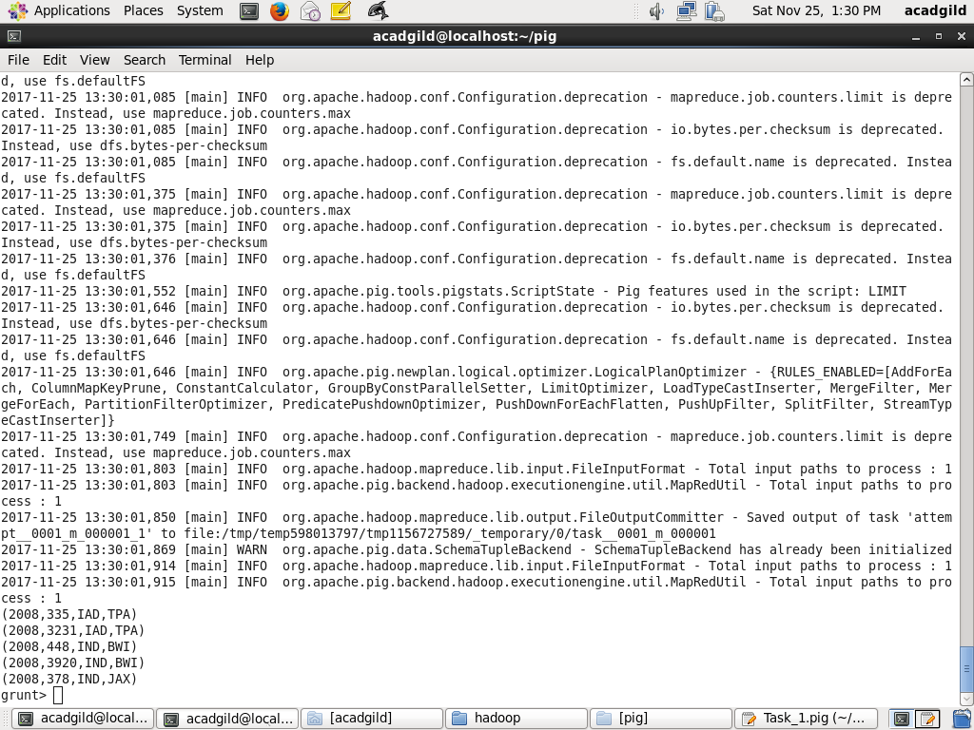

C = filter B by dest is not null;

C_LIMIT = LIMIT C 15;

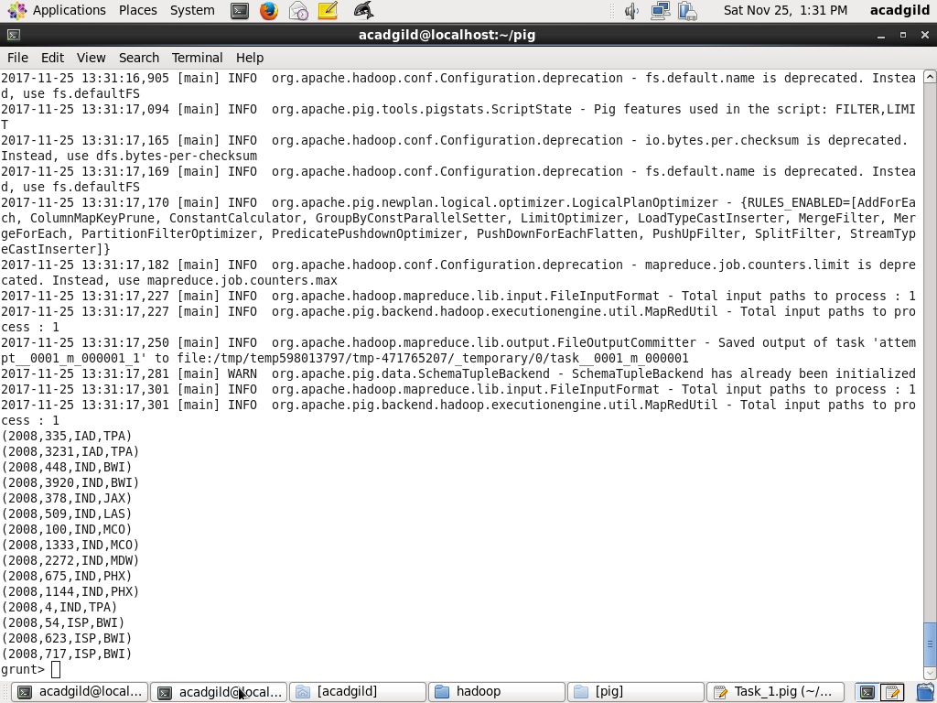

D = group C by dest;

D_LIMIT = LIMIT D 15;



E = foreach D generate group, COUNT(C.dest);

E_LIMIT = LIMIT E 15;

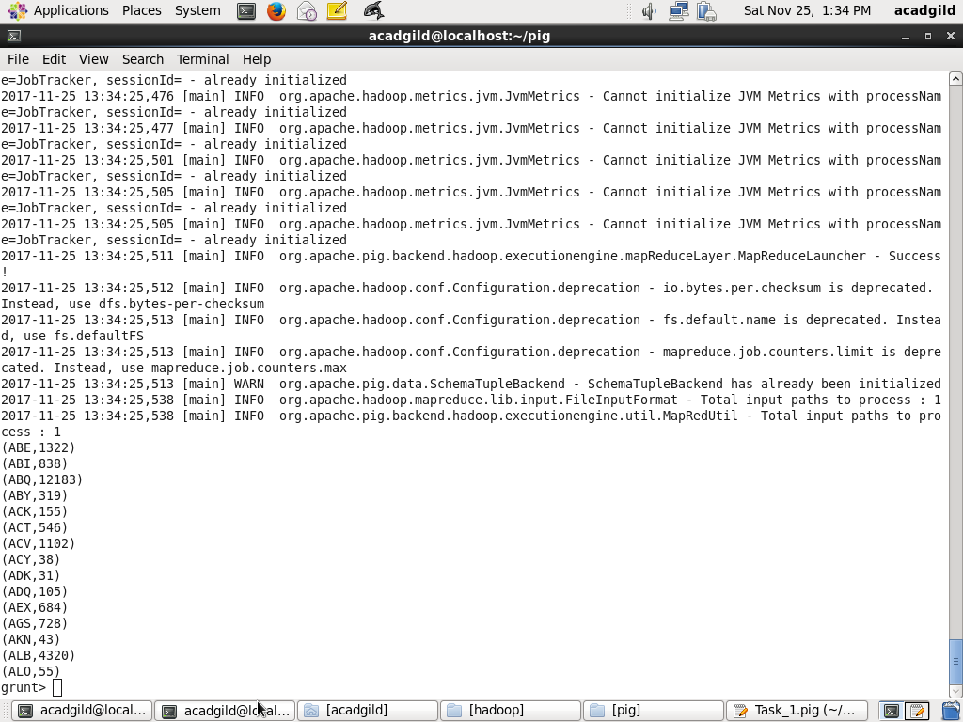

F = order E by $1 DESC;

Result = LIMIT F 5;

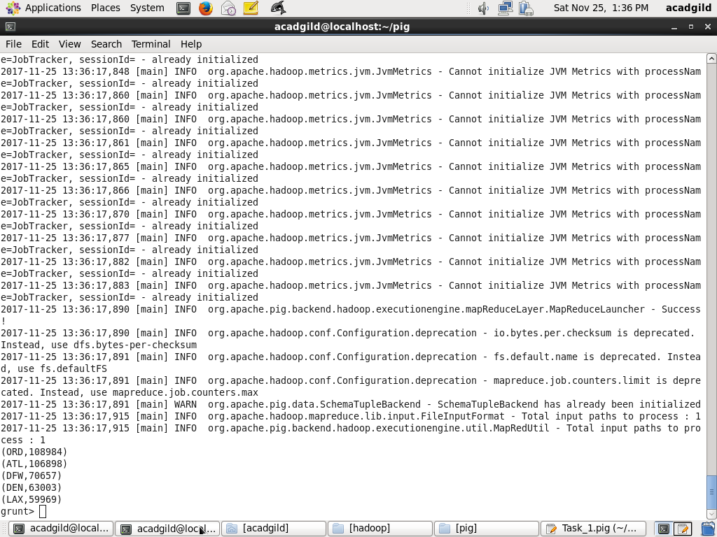

A1 = load 'airports.csv' USING org.apache.pig.piggybank.storage.CSVExcelStorage(',','NO_MULTILINE','UNIX','SKIP_INPUT_HEADER');

A2 = foreach A1 generate (chararray)$0 as dest, (chararray)$2 as city, (chararray)$4 as country;

joined_table = join Result by $0, A2 by dest;

dump joined_table;

